

**A**

**MINOR PROJECT REPORT**

**On**

**Level Monitoring Smart Dustbin using Arduino**

Submitted for partial fulfilment of the requirement for the degree of Master of Technology

(Internet of Things)

By

Mr. Amit Singh (M.Tech/2022/21) (2022-2024)

&

Miss. Srija Loya (M.Tech/2022/23) (2022-2024)

**Submitted**

**To**

**School of Instrumentation**

**Devi Ahilya Vishwavidhyalaya**

**Devi Ahilya Vishwavidhyalaya, Indore (M.P)**

**School of Instrumentation**



**CERTIFICATE**

This is to certify that this minor project entitled “**Level Monitoring Smart Dustbin using Arduino**” submitted by Mr. Amit Singh and Miss. Srija Loya accepted for the partial fulfilment of the requirement of the award of the degree of Master of Technology of Internet of Things.

**Date:**

**Declaration**

We hereby declare that the work, which is being presented in the Minor project, entitled “Level Monitoring Smart Dustbin using Arduino” partial fulfilment of the requirements for the award of degree of Master of Technology in Internet of things, submitted in the department of school of instrumentation, Devi Ahilya Vishwavidhyalaya, Indore is an authentic record of my own work carried under the guidance of “Dr Ratnesh Gupta, Devi Ahilya Vishwavidhyalaya”. We have not submitted the matter embodied in this report for the award of any other degree.

Date:

Place: Mr. Amit Singh

Miss. Srija Loya

**ACKNOWLEDGEMENT**

With great pleasure and sense of obligation we express our heartfelt gratitude to our project guide Dr Ratnesh Gupta, HOD, School of Instrumentation, Devi Ahilya Vishwavidhyalaya, Indore. We take pride in saying that we have successfully completed the dissertation under his persistent encouragement perpetual motivation, everlasting patience and valuable technical inputs in discussion during process of project work have benefitted us to an extent, which is beyond expression and he also took pains for imparting expert knowledge for design and development of the dissertation.

We wish to acknowledge our deep sense of gratitude Mr. Shashi Ranjan (Research Scholar, SOI, DAVV), Indore for providing all the necessary resources and lab facilities. We would like to give warm compression thanks to Department of school of instrumentation for providing academic environment needed for successful completion of major project. The Successful completion of the minor project is generally not an individual effort. It is an outcome of the cumulative effort of the number of persons, each having their own importance to the objective. And at last but not least our precious family members were always behind us to encourage for pursuing studies.

Mr. Amit Singh

Miss. Srija Loya

**Contents**

1. INTRODUCTION
2. METHODOLOGY
   1. BLOCK DIAGRAM
3. HARDWARE DESCRIPTION
   1. COMPONENTS USED

3.1.1ARDUINO UNO

* + 1. ULTRASONIC SENSOR
    2. I2C-LCD DISPLAY
    3. SERVO MOTOR

1. SOFTWARE SPECIFICATIONS
   1. ARDUINO IDE
   2. CODE OF THE PROJECT
2. WORKING
3. CONCLUSION
4. FURTHER STUDY
5. **Introduction:**
   1. **Aim:**

The main aim of the project is to sense the object which is there at the front of the dustbin using the HC-SR04 ultrasonic sensor, which sends the signals to the arduino which is used to open the lid of the bin. The lid will be closed after certain amount of time by using the same HC-SR04 Ultrasonic Sensor. After closing the dustbin lid, the HC-SR04 ultrasonic sensor is used to level of the dustbin, which sends signals to the arduino uno and the arduino sends the signals to the I2C LCD display, and then the level of the dustbin is displayed in the I2C LCD display.

* 1. **Objectives:**

As, the population is growing day-by day, there are many problems rising in the world. One of the main problem affecting both human health and also the eco-system is the waste management. The waste is either thrown in the dustbin even though it is getting filled or thrown on the roads. In some situations, though the waste is thrown into the dustbin, the people will not close the lids of the dustbin, which causes the air pollution. In rainy seasons, the problem of waste management will be more. The Dustbin falls into the water and the same water will be mixed into the oceans or the rivers or lakes, which makes the water pollution. The waste when thrown outside, the soil gets polluted due to the plastic waste. The plastic takes a lot of time to get decomposed. Before, it gets decomposed; the animals will eat the waste which is hazardous to all living beings. During the rainy seasons, the waste will block the proper flow of the water in dams or in the lakes, which develops the stagnate water, which in further leads to the increase in mosquitos and flies. This leads to the hazardous health issues of human health and also spoils the quality of the food. This waste management is done in a smarter way using IoT, which motivates the people in a creative and smarter way. Now-a-days the technology up gradation is growing faster and also people are acquiring for smarter things. This project “**Level Monitoring Smart Dustbin using arduino**” is very helpful in the waste management. By using this smart dustbin, the people no need to open the lid of the dustbin and can also see the level of the waste present in the dustbin, so that people will not through the waste in the dustbin when it gets filled. Our main objective in making this project is to do the proper and disciplined way of waste management. Arduino UNO, I2C LCD Display, two HC-SR04 Ultrasonic Sensors and Arduino IDE are the basic requirements in making this smart dustbin. This is the main objective in making the project is to make the people do proper waste management and maintain the human health and also the eco-system well. The hardware used in making this project is not much expensive. Anyone can afford this Level monitoring smart dustbin using Arduino. This is very simple to understand and use. The power consumption will be also less. We can also determine the waste level present inside the dustbin, which helps the people to know the level of the waste and if the level is filled, people will understand that the capacity is filled and doesn’t throw the waste in it.

1. **Methodology:**
   1. **Block Diagram:**

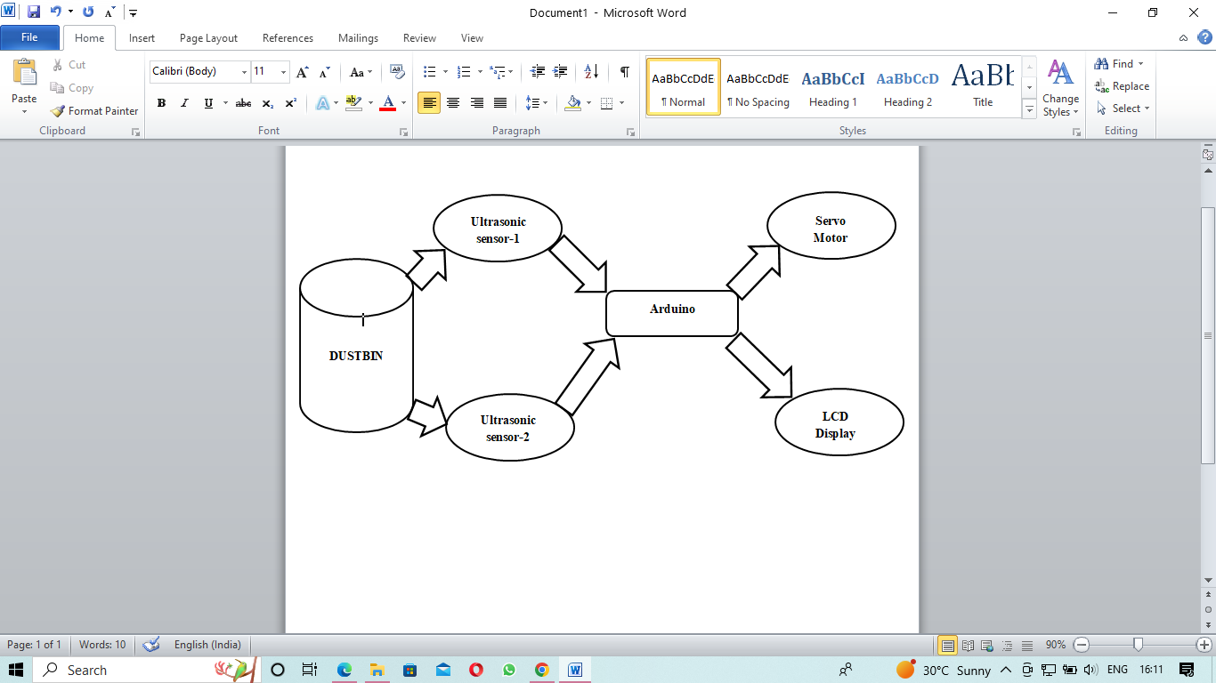

The above block diagram represents the working methodology of the “Level Monitoring Smart Dustbin”. This smart dustbin is made up of 2 ultrasonic sensors, namely Ultrasonic sensor-1 and ultrasonic sensor-2, which are connected to the arduino. The ultrasonic sensor-1 is used to sense the object present in front of the dustbin, sense the objects and send the signals to the arduino. The arduino processes the signals sent by ultrasonic sensor -1 and sends the signals to the “Servo Motor”, which is used to open the lid of the dustbin. After some seconds the servo motor is used closes the lid of the dustbin.

The ultrasonic sensor-2 is used to detect the level of the dustbin. The ultrasonic sensor-2 senses the waste level present in the dustbin and sends the signals to the arduino. The arduino processes the signals and sends the signals to the LCD display, which is used to see the level of the dustbin. This is working of the “Level monitoring Smart Dustbin.”

1. **Hardware Description:**
   1. **Components used:**

These are the following components that are used in making a **“Level monitoring smart dustbin using arduino”**.

* 1 Arduino UNO
* 1 I2C LCD
* 2 Ultrasonic sensors
* 1 Servo motor
* Red and green color LEDs
* Connecting wires
* Dustbin
  1. **Arduino UNO:**

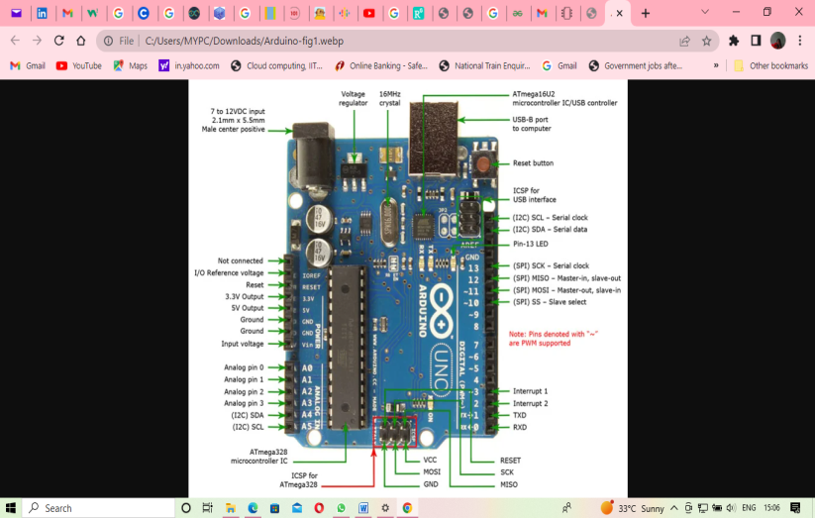

The Arduino UNO is an open source microcontroller board in which is based on ATmega 328P microcontroller and developed by arduino.cc. This arduino board consists of the sets of digital and analog input and output pins. It consists of 14 digital I/O pins, programmable with the Arduino IDE where type B USB cable is used. This board is powered by either USB cable or external battery which is of 9-volts.

* 1. **HC-SR04 Ultrasonic Sensor:**

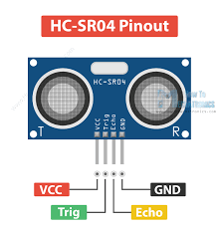

The HC-SR04 ultrasonic sensor uses SONAR (sound navigation and ranging) technique to determine the distance of the object, which uses non-contact range detection with high accuracy and stable readings in an easy to use package from 2cms to 400cms. It is a complete ultrasonic transmitter and receiver module. The basic principle on which the HC-SR04 ultrasonic sensor works is:

* Using IO trigger for at least 10 microseconds high level signal,
* The module automatically sends 40kHz and detect whether the pulse signal back.
* If the signal back, through high level, time of high output IO duration is the time from sending ultrasonic to returning.

These are the following specifications of the HC-SR04 ultrasonic sensor:

1. Working voltage – DC 5V
2. Working current – 15mA
3. Working frequency – 40 Hz
4. Max Range – 4m
5. Min Range – 2cm
6. Measuring angle – 2 degree
7. Trigger Input signal – 10 micro seconds TTL pulse
8. Echo Output signal – Input TTL lever signal and the range in proportion
9. Dimension – 45*20*15mm

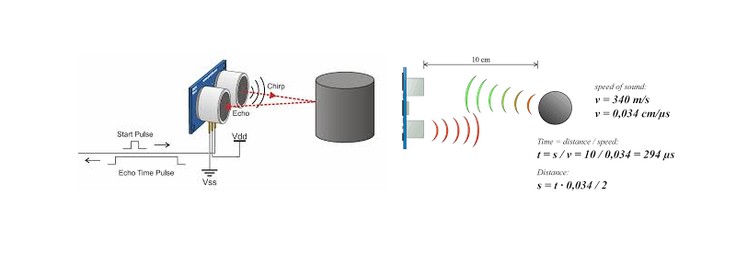

The following is the diagram which represents the working of the ultrasonic sensor.

The ultrasonic sensor has 4 pins, they are Vcc which gets voltage from this pin, TRIG pin, is an input pin, which has to be kept high for 10 micro seconds which has to initialize measurement by sending ultrasonic wave. ECHO pin is an output pin, which goes high for a period of time which will be equal to the time taken for the ultrasonic wave to return back to the sensor and the last pin is the ground (GND) pin.

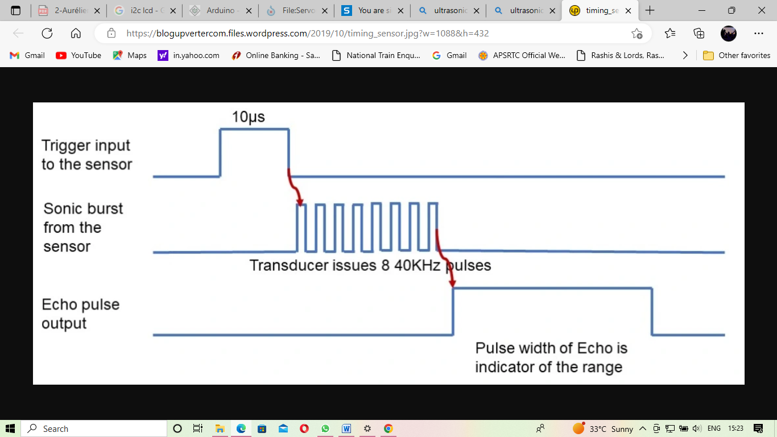

The following is the timing diagram of the HC-SR04 ultrasonic sensor.

The minimum distance that the HC-SR04 ultrasonic sensor is calculated by using the below formula:

Distance =

Where, speed of the ultrasonic waves = 340 m/s

= 0.034 cm/ microseconds

Time = 294 micro seconds

Distance = = = 4.998 cms

Two ultrasonic sensors are used in this project. One ultrasonic sensor is used to sense the object which comes near the dustbin and other sensor is used to measure the depth of the dustbin.

These are the following connections of the ultrasonic sensor-1 to arduino.

* Vcc pin of ultrasonic sensor is connected to 5V pin of arduino.
* TRIG pin of ultrasonic sensor is connected to digital pin “D9” of the arduino.
* ECHO pin of ultrasonic sensor is connected to the digital pin “D10” of the arduino.
* GND pin of ultrasonic sensor is connected to the GND pin of the arduino.

These are the following connections of the ultrasonic sensor-2 to the arduino:

* Vcc pin of ultrasonic sensor to the 5V pin of the arduino.
* TRIG pin of ultrasonic sensor is connected to the digital pin “D6” of the arduino.
* ECHO pin of the ultrasonic sensor is connected to the digital pin D7 of the arduino.
* GND pin of the ultrasonic sensor is connected to the GND pin of the arduino.
  1. **I2C-LCD 16x2 Display:**

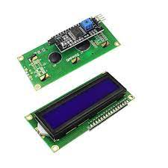

The I2C LCD 16x2 display is the character LCD is ideal for displaying the text and special characters. LCD has a small add-on circuit mounted on the back of the LCD module, which features a controller ship handling I2C communications and an adjustable potentiometer for changing the intensity of the LED backlight. The main advantage of the I2C LCD 16x2 display wiring is straight forward, which requires only two data pins to control the LCD. LCD has 4 pins namely, Vcc, SDA, SCL and GND.

The Vcc pin of the I2C LCD 16x2 display is connected to the 5V pin of the arduino. The SDA pin of the I2C LCD 16x2 display is connected to the analog pin “A4” of the arduino. The SCL pin of the I2C is connected to the analog pin “A5” of the arduino and the GND pin of the I2C is connected to the GND of the arduino.

Why I2C LCD 16x2 display only?

The main advantage in using the I2C LCD 16x2 display, instead of using LCD 16x2 display is, the wiring is simple in I2C LCD 16x2 display. We need only 2 pins to control the whole LCD. While standard LCD displays need 12 connections while can be a problem if there are no GPIO (general purpose input/ output) pins available.

These are some of the features of the I2C LCD 16x2 display:

1. Display type: Negative white on Blue black light.
2. I2C address: 0x38 – 0x3F but the default address is 0x3F
3. Supply voltage: 5V
4. Interface: I2C to 4bits LCD data and control lines
5. Contrast adjustment: Built-in potentiometer
6. Backlight control: Firmware or jumper wire
7. Board size: 80x36 mm
   1. **SG-90 Servo Motor:**

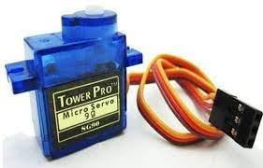

A SG-90 servo motor is a rotatory actuator or linear actuator which is used for precise control angular or linear position, velocity and acceleration which consists of a suitable motor. The motor is coupled to a sensor for position feedback. These servo motors are much suitable in closed loop control system such as robotics, automated manufacturing. Servo motor SG-90 can rotate approximately 180 degrees (90o in each direction).

The SG-90 Servo motor has 3 wires. They are, power wire, ground wire and the control wire. The control wire is used to communicate the angle, which is determined by the duration of a pulse that is applied to the control wire, known as pulse coded modulation. The servo expects to see a pulse every 20 milliseconds.

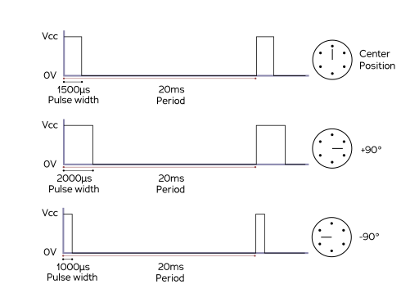

The 1.5 millisecond pulse will make the motor to turn to the 90 degree position. If the pulse is shorter than 1.5 milliseconds, then the motor will move the shaft closer to 0 degrees. If the pulse is longer than 1.5 milliseconds, the shaft turns closer to 180 degrees.

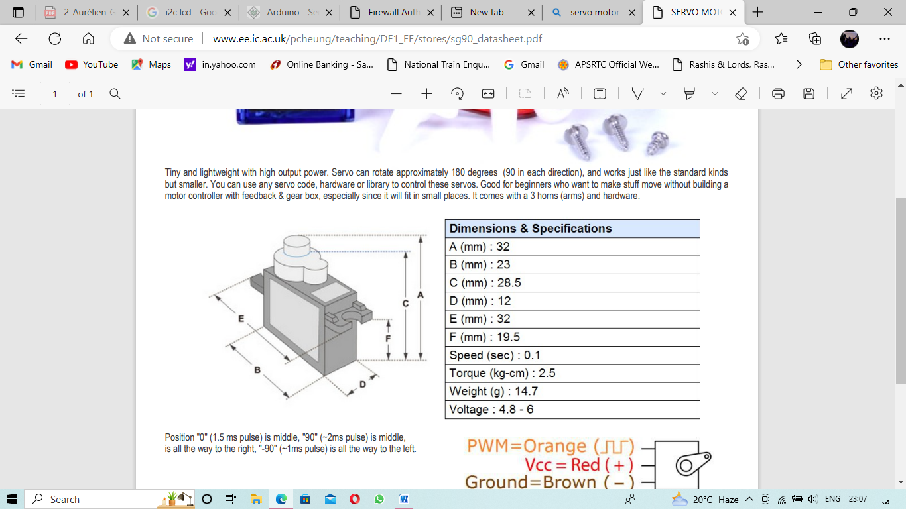 

These are the following connections between servo motor and the arduino:

* The power wire or PWR pin is connected to the 5V pin of the arduino.
* The SIG pin or the control wire is connected to the digital pin D3 pin of the arduino.
* The GND pin of the servo motor is connected to the GND pin of the arduino.

Why SG-90 Servo Motor?

The following are the features of SG-90 Servo Motor:

1. Operating Voltage - +5V
2. Torque – 2.5kg/cm
3. Operating speed – 0.1s/60o
4. Gear type – Plastic
5. Rotation – 0o – 180o
6. Weight of motor – 9gm

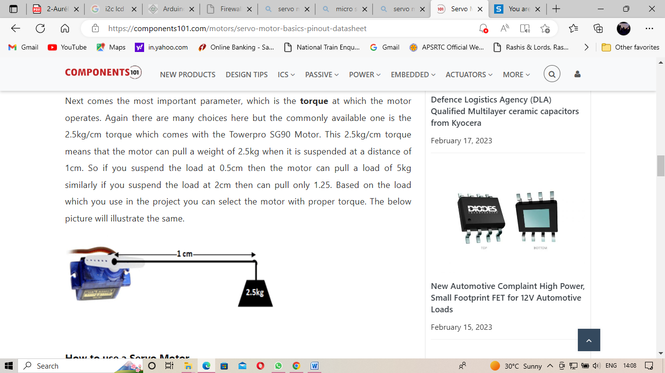

In the specifications, we can see the torque of the SG-90 Servo motor is 2.5 kg/cm, which means the weight of 2.5 kgs can be pulled by the motor if it is suspended at a distance of 1cm. So, if we suspend the load at a distance of 0.5cm, we can suspend a load of 5kg, in the same way, if we suspend the load at a distance of 2cm, we can suspend the load of 1.25kg.

1. **SOFTWARE DESCRIPTION**
   1. **ARDUINO IDE:**

**STEP-1:** Open the Arduino IDE and write down the code shown below.

**STEP-2:** Now go to the tools option, in that we can see “board manager” and select the board we are using. Here we are using the Arduino board, so we will select the board open “Arduino UNO”.

**STEP-3:** Now compile the code. After successful compilation of the code, upload the code into arduino using the cable.

After successful uploading of the code, now test the application, whether the smart dustbin is working according to the need or not. If there is any error in working of the smart dustbin, make the changes accordingly.

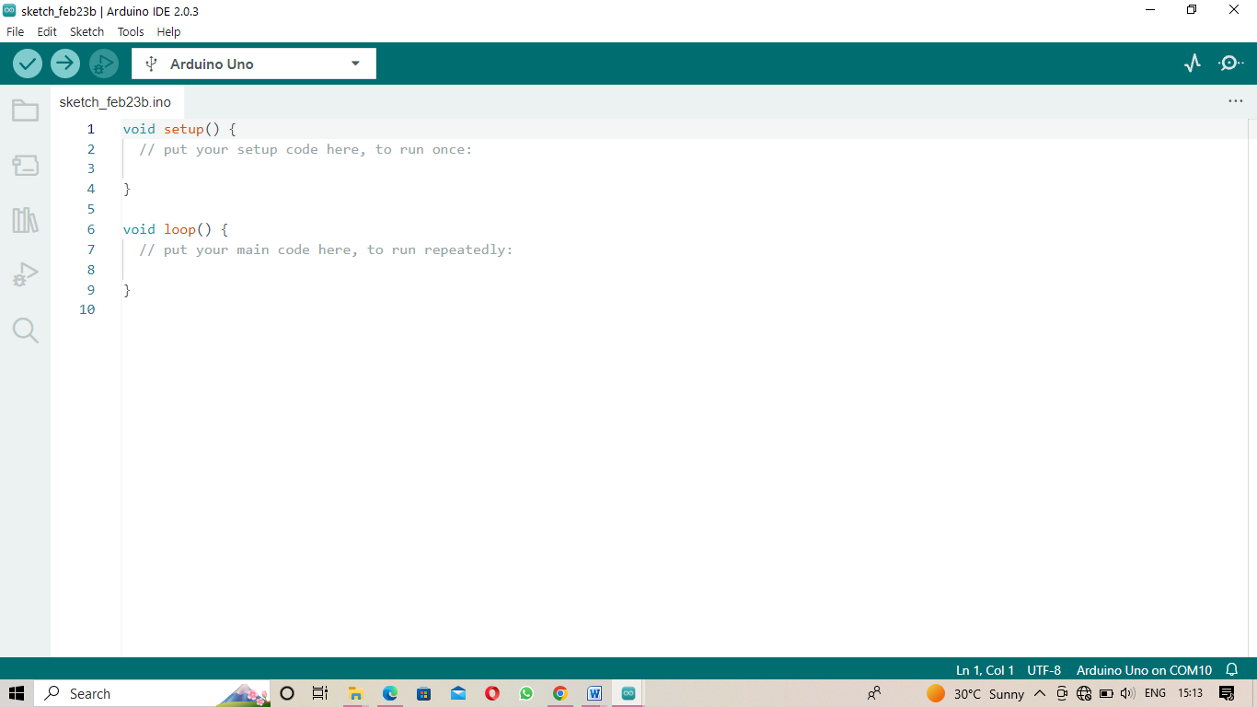

* 1. **CODE OF THE PROJECT**

#include<Servo.h>

#include <LiquidCrystal_I2C.h>

#include <Wire.h>

Servo s1;

LiquidCrystal_I2C lcd (0x3F, 16, 2);

//part 1

int trigPin = 9; //sensor 1

int echoPin = 10; //sensor 1

int led = 2; //green led

//part 2

const int trigPin2 = 6; // sensor 2.

const int echoPin2 = 7; // sensor 2

int pause1 = 5; //5 millsecond delay

int pause2 = 10; //10 millisecond delay

int Distance;

int Duration;

int percentage1;

int percentage;

int TankDepth1 = 26;

const int MAX_DISTANCE = 30;

void setup() {

  Serial.begin(9600);

  s1.attach(3); // servo motor pin 3

  pinMode(led, OUTPUT);

  pinMode(trigPin, OUTPUT);

  pinMode(echoPin, INPUT);

  pinMode (trigPin2, OUTPUT);

  pinMode (echoPin2, INPUT);

  lcd.begin();

  lcd.clear();

}

void loop() {

// part 1

  long duration, distance;

  digitalWrite(trigPin,HIGH);

  delayMicroseconds(10);

  digitalWrite(trigPin, LOW);

  duration=pulseIn(echoPin, HIGH);

  distance =(duration/2)/29.1;

  Serial.print(distance);

  Serial.println("CM");

  delay(10);

// part 2

digitalWrite (trigPin2, LOW);

delay(pause1);

digitalWrite (trigPin2, HIGH);

delay(pause2);

digitalWrite (trigPin2, LOW);

Duration = pulseIn(echoPin2, HIGH);

Distance = Duration * 0.034/2; //convert duration to distance in cm

percentage1 = (100*Distance/TankDepth1); //convert distance to percent

percentage = 100 - percentage1; // makes the percentage 100-0

lcd.setCursor(5,0);

lcd.print(percentage);

lcd.println(" %        ");

lcd.setCursor(2,1);

lcd.println ("DUSTBIN LEVEL  ");

delay(1000);

 if((distance<=30))

  {

    digitalWrite(led, HIGH);

    s1.write(0);

    delay(8000);

    s1.write(90);

    delay(1000);

}

   else if(distance>30)

 {

     digitalWrite(led, LOW);

   }

}

1. **Working:**

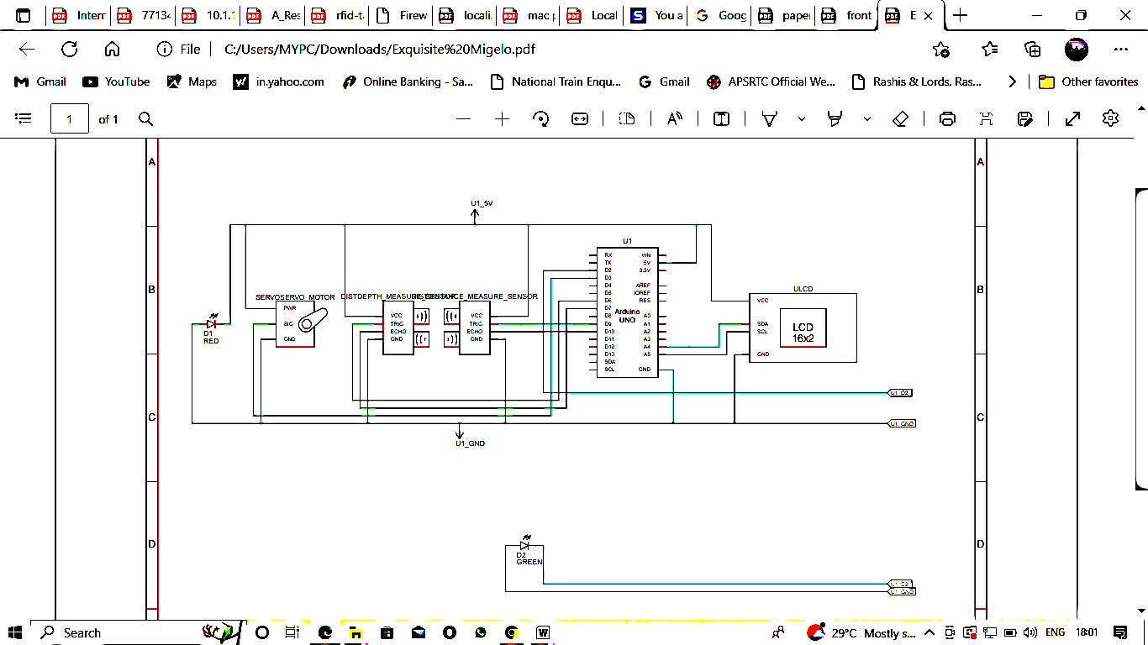

**Fig: Circuit diagram**

**Step-1:** After wiring and attaching all the devices as shown in the above circuit diagram.

**Step-2:** After connecting all the devices, now upload the below program by compiling the program using arduino IDE and upload the program in the arduino and supply power to the circuit.

**Step-3:** When the system is powered ON, the arduino keeps monitoring the objects which come in range of the sensor-1, detects the object and opens the lid and after 10seconds of delay, the lid will get closed.

**Step-4:** Now, the arduino monitors the level of the garbage through the sensor-2 and displays the level in the LCD display.

The whole working of the “Level Monitoring Smart Dustbin” is shown in the below figures.

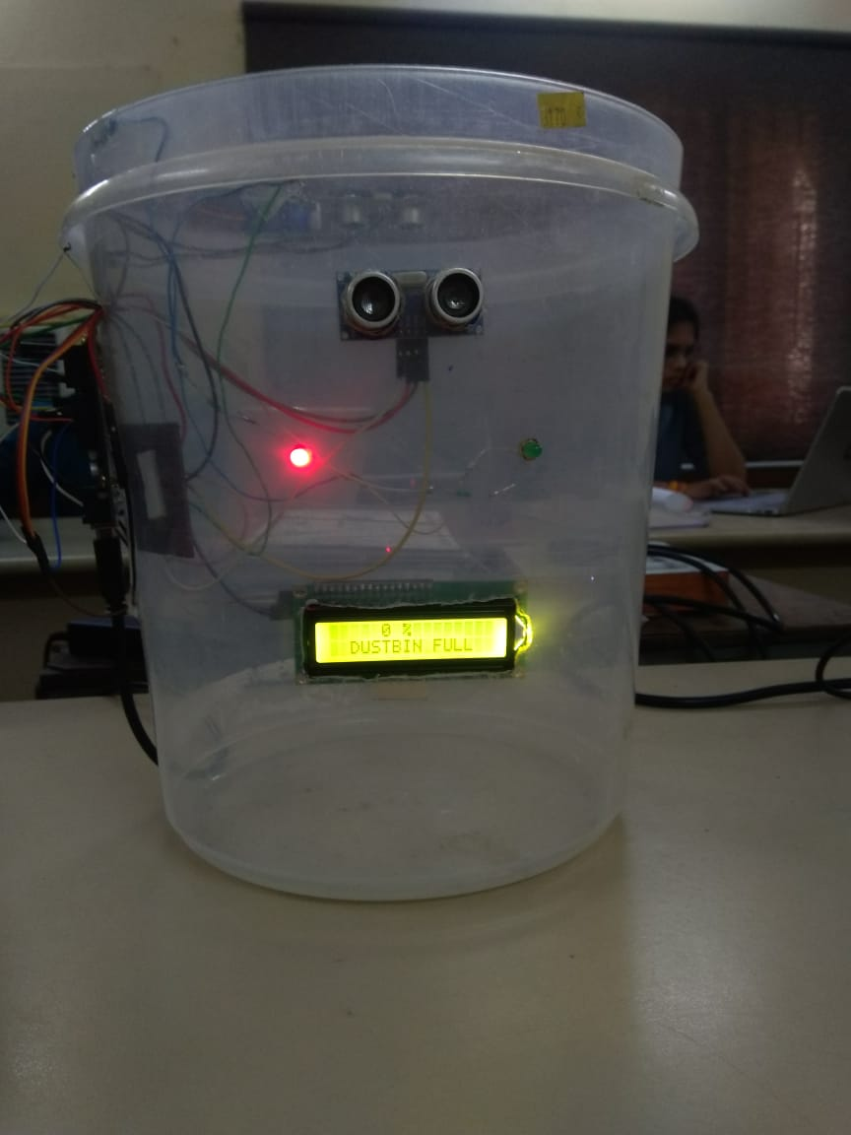

1. **Conclusion:**

The dustbin is be able to open the lid using the HC-SR04 Ultrasonic sensor and also level the dustbin garbage level using the another HC-SR04 Ultrasonic sensor and could display the garbage level in the I2C LCD display. In this project, we had used 2 HC-SR04 Ultrasonic sensors, one I2C LCD 16x2 display, an Arduino UNO, one SG-90 Servo Motor and a dustbin. By using these components, the Level Monitoring Smart Dustbin using arduino is made. The one of the ultrasonic sensor is used to detect the objects, which comes in front of the dustbin and open the lid of the dustbin. Another HC-SR04 Ultrasonic Sensor is present inside the top of the dustbin, which is used to know the level of the waste present inside the dustbin. The I2C LCD 16x2 display is used to display the waste level of the dustbin. The Arduino UNO co-ordinates all these components in the dustbin. By using all these components the smart dustbin was made.

There are some failures in this project. They are:

1. The lid of the dustbin lid opens, even if the non- human or any non-living thing comes in front of the dustbin, because we are using the HC-SR04 Ultrasonic sensor.
2. The display about the waste level of the dustbin will be accurate only if the waste is solid waste.
3. **Further study:**

The further development of this project is done by using Wi-Fi Module so that when the dustbin is full, the user will get the warning to his/her phone or any linked device and also can monitor the dustbin level whenever the user wants to see the level of the dustbin.

**References:**

1. https://handsontec.com/dataspecs/module/I2C_1602_LCD.pdf
2. http://www.ee.ic.ac.uk/pcheung/teaching/DE1_EE/stores/sg90_datasheet.pdf
3. HC-SR04 (sparkfun.cohttps://cdn.sparkfun.com/datasheets/Sensors/Proximity/HCSR04.pdfm)
4. Arduino - Hhttps://www.arduino.cc/ome
5. SmartDuhttps://www.researchgate.net/publication/349759431_Project_Report_RC_Smart_Dustbinstbin (researchgate.net)